Student: Faruk Hodžić, 1210195

Subject: Analog Electronics II

January 26, 2017

International University of Sarajevo

**VOLTAGE DIVIDER BJT AMPLIFIER RESPONSE**

**(Project)**

For my project, I chose the most frequently used Bipolar Junction Transistor (BJT) amplifier, the capacitively coupled voltage divider amplifier. They come in two forms, and both are pretty much the same at first sight. The difference is that one circuit comes with and the other comes without a swamping resistor. The advantage of a circuit with this resistor is that we can control the AC gain of the amplifier over the full range of input frequencies. Our task was to take any interesting topic from Analog Electronics and to either write a research paper or make a small project. As I already did a very useful project in another course, I took the same one and just upgraded it a little bit. I chose MATLAB as the tool for this project, since it is much more accessible and easier to function with. The code itself is very easy and not at all astronomical. It contains a few resistance, capacitance, and frequency formulas which help us find five critical frequency responses of a BJT amplifier. There are three low frequency responses: input frequency response, bypass frequency response, and output frequency response, respectively. The remaining are high frequency responses: input frequency response and output frequency response. The five together create a frequency response of the amplifier and could be used to find the lower and upper dominant frequencies which determine the bandwidth of the amplifier, and also the unity gain of the amplifier which is the product of the bandwidth and the mid gain. I named my files “VDBJTA” with extensions .m and .fig. The two come as a pair, one is the code in the script, with all the function creators and callbacks, that is the m-file obviously, and the other is the .fig file, the GUI itself. The m-file is very long, consisting of many explanations and a Callback and Create functions for every component in the GUI. The GUI I made consists of 14 variables, which are the components of the circuit and some extra needed information. The rest of the components in the User Interface are the field for the resulting frequency responses and the fields for bandwidth and unity gain. In addition to these two files, for the sake of simplicity and better insight of what is being calculated in the background, rather than just the frequency responses, I made another m-file in MATLAB, called “BJTAmplifierFrequencyResponse”, without a GUI which could be used directly from the command window, with all the data visible. The difference between these two is also the fact that the program with the GUI, asks the user to enter the value of r’e, while the simpler doesn’t need it, as it calculates it’s value and returns it. The program is not very creative but since the frequency responses deal with a lot of formulas, operations, different powers of components, I figured it might come in handy and hopefully save some time for anyone that might be using it. Other than these three files, you will find attached two word files. One contains the code I had to enter in the m-file related to the GUI and the other is the code for the simple MATLAB program I made for this problem.

Example:

This is an example of a voltage divider BJT amplifier from the textbook and the values used in my program evaluation are same as in this figure.

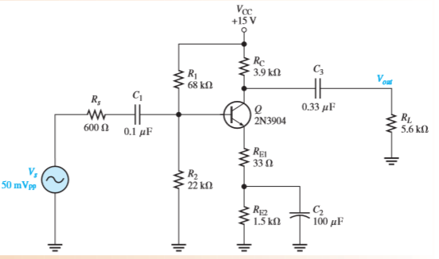

This is the part of the Graphical User Interface where you enter the component values.

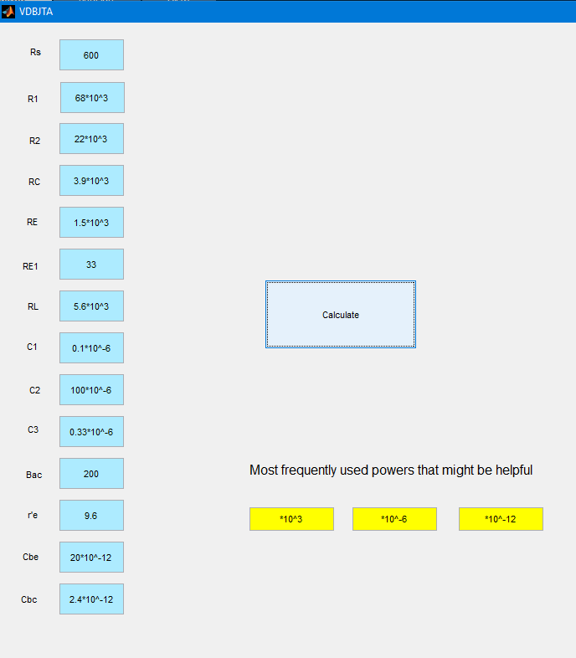

And finally the returned values of the desired results for the low and high frequency responses and for the bandwidth and the unity gain.

